**Assignments on Lambda Expression:**

**interface** operation{

**int** op(**int** a, **int** b);

}

**public** **class** MyLambda {

**public** **static** **void** main(String[] args) {

operation addition = (a,b) -> a+b;

System.***out***.println(addition.op(10,20));

operation subtract = (a,b) -> a-b;

System.***out***.println(subtract.op(20,10));

operation multiply = (a,b) -> a*b;

System.***out***.println(multiply.op(10,20));

operation divison = (a,b) -> a/b;

System.***out***.println(divison.op(20,10));

}

}

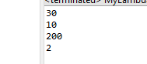**Output:**

3.

Predicate:

**import** java.lang.reflect.Array;

**import** java.util.Arrays;

**import** java.util.List;

**import** java.util.function.Predicate;

**public** **class** MyLambda {

**public** **static** **void** main(String[] args) {

List<String> language = Arrays.*asList*("Sawan", "Anu", "Ananya","Sum", "Anirban", "Rudy");

System.***out***.println("Print names whose length greater than 4: ");

*filter*(language, p1 -> p1.length()>4);

System.***out***.println("Names which starts with A: ");

*filter*(language, p -> p.startsWith("A"));

}

**public** **static** **void** filter(List<String> name, Predicate<String> condition ) {

**for**(String s : name) {

**if**(condition.test(s)) {

System.***out***.println(s);

}

}

}

}

Output:

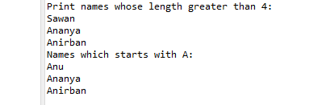

Consumer:

**import** java.lang.reflect.Array;

**import** java.util.Arrays;

**import** java.util.List;

**import** java.util.function.Predicate;

**public** **class** MyLambda {

**public** **static** **void** main(String[] args) {

List<String> language = Arrays.*asList*("Sawan", "Anu", "Ananya","Sum", "Anirban", "Rudy");

System.***out***.println("Print names whose length greater than 4: ");

*filter*(language, p1 -> p1.length()>4 ,p-> System.***out***.println(p));

System.***out***.println("Names which starts with A: ");

*filter*(language, p -> p.startsWith("A") ,p-> System.***out***.println(p));

}

**public** **static** **void** filter(List<String> name, Predicate<String> condition, Consumer<String> consumer ) {

**for**(String s : name) {

**if**(condition.test(s)) {

consumer.accept(s);

}

}

}

}

Output:

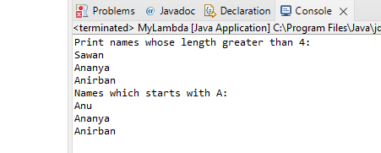

4.

**import** java.util.Arrays;

**import** java.util.List;

**import** java.util.*;

**public** **class** MyLambda {

**public** **static** **void** main(String[] args) {

ArrayList<String> names = **new** ArrayList<String>();

names.add("Sawan");

names.add("Anu");

names.add("Ananya");

names.add("Sum");

names.add("Anirban");

names.add("Rudy");

names.removeIf(a -> (a.length() % 2 !=0));

**for**(String i : names) {

System.***out***.println(i);

}

}

}

Output:

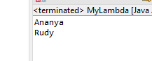

6.

**import** java.util.Arrays;

**import** java.util.List;

**import** java.util.*;

**public** **class** MyLambda {

**public** **static** **void** main(String[] args) {

ArrayList<String> names = **new** ArrayList<String>();

names.add("Sawan");

names.add("Anu");

names.add("Ananya");

names.add("Sum");

names.add("Anirban");

names.add("Rudy");

names.replaceAll(e-> e.toUpperCase());

System.***out***.println(names);

// for(String i : names) {

// System.out.println(i);

// }

}

}

Output:

